Tatton Wildlife Newsletter – Summer
The natural world is busy making the most of the longer, warmer days and there is a plentiful supply of food to raise their young. It is a perfect time to get out and enjoy all that the parkland has to offer and a place to relax and enjoy the sunnier days.
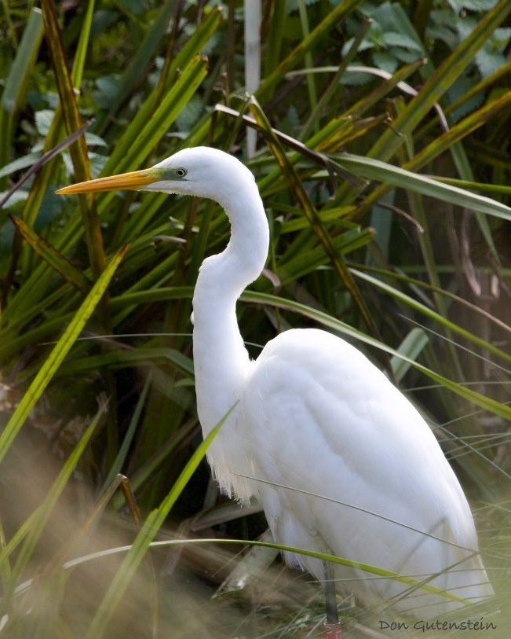
Birds
The great white egret that has the red ring ‘AFU’ and fledged at Ham Wall RSPB last year, is still with us. Occasionally he is seen with another individual and it is not known whether this second bird is a male or a female. He is doing well as 70% of great white egret juveniles do not make it through their first winter. They don’t usually nest until they are two years old, sometimes three. The photograph opposite was taken at Tatton by Don Gutenstein.
The heronry at Higmere has done reasonably well this year with 13 nests occupied. Kingfishers have been seen regularly, and they tend to do well after a mild winter. Cuckoos have been heard at Tatton this year, most notably one at the southern end of Tatton Mere near to the reedbed. Reed warblers are a favoured choice of host species to lay the egg into as the cuckoo famously lays its eggs in other bird’s nests.
Butterflies and Flowers
The Tatton rangers will be taking part in a national butterfly survey again this year and although numbers were down last year, we hope this season will be an improvement. Already we have seen a small copper which wasn’t seen here during the survey last year and although numbers are low, there have been a nice variety of species. Butterflies rely on wildflowers, and we make sure that the parkland is not over-grazed which allows a proliferation of grassland flowers. In summer, if you look closely, you can find harebells, tormentil, speedwell and other species among the grasses. The grasses and sedges themselves are a valuable component of good habitat.
Deer

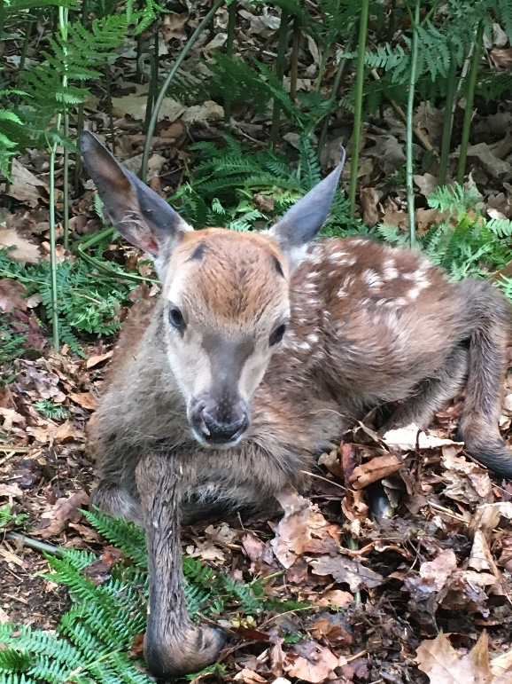
Summer is calving time when the hinds and does split off from the herd to literally drop their young. They lie low after being born in a clump of nettles or by a fallen branch where hopefully they can remain undisturbed. They have no scent at this point and do not defecate, protecting them from predators. If you see a hind or doe alone, she probably has a calf or fawn nearby so needs to be left alone. After a few days the young will be on their feet close behind the mother. The picture opposite was taken from far away, it is important to keep your distance.
The males are now ‘in-velvet’. The abundant grazing gives them ample opportunity to direct resources into growing their antlers and by late August, they will be fraying the velvet off preparing for the rut to come. This is arguably the season when the deer look at their best as they have moulted to their beautiful summer coats, and they have plenty of good grass to eat and are in good condition.

Summer Woodlands
Woodlands are fully alive during summer. Our native trees host hundreds of insect species which in turn provide food for animals and birds along with nest sites and habitats to live in. They are a fundamental foundation to ecosystems whether it be food for fungi or the air we breathe. Oak trees are common at Tatton, and they are undoubtedly one of the most important along with ash, chestnut and beech. The spring scents of hawthorn give way to the wonderful scent of lime trees in June. They also offer shade from the summer sun or a brief shelter from a summer downpour.

Compiled by Tatton’s Ranger Team

